Chapter 16, Problem 63.

Consider the parallel RLC circuit of Fig. 16.86. Find v(t) and i(t) given that
v(0) = 5 V and i(0) = –2 A.

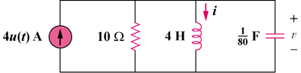

Figure 16.86
For Prob. 16.63.

